FA19-BSE-101

Khadija-Tul-Kubrra

A:

1. Deprecated Api

There is no deprecated issue here

1. Potential Issues

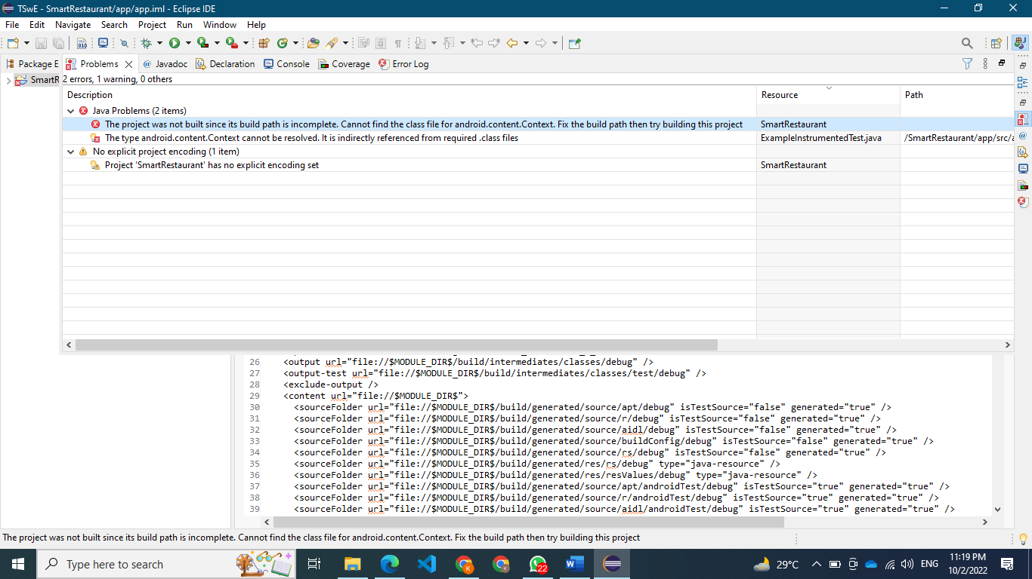

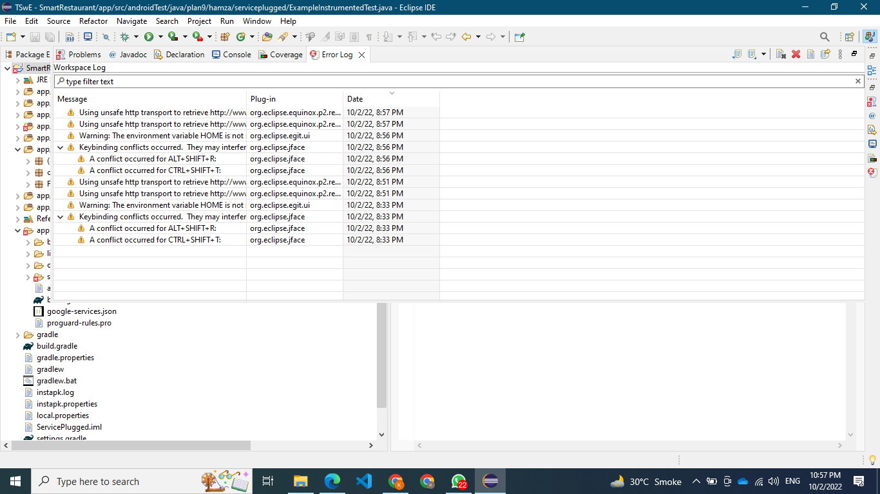

1. Missing of technical documentation

There is no missing technical documentation

B:

1: I view code the indentation error, naming conventions etc all are already presented

2:

1. Change is absolutely required. Behavior is critically broken/buggy.
2. Change is highly recommended. Behavior is quite likely to be broken/buggy.
3. Change recommended. Behavior is confusing, perhaps buggy, and/or against standards/best practices.
4. Change optional. Behavior is not likely to be buggy, but more just flies in the face of standards/style/good taste.
5. Change is highly optional.

3:

Code should be neat and clean

Name of classes,function and methods meaningful

Code must be commented

Code must have short strategies

4: Its not good practice to use the short name of the class. Select a meaningful name of class that will be helpful for the future.

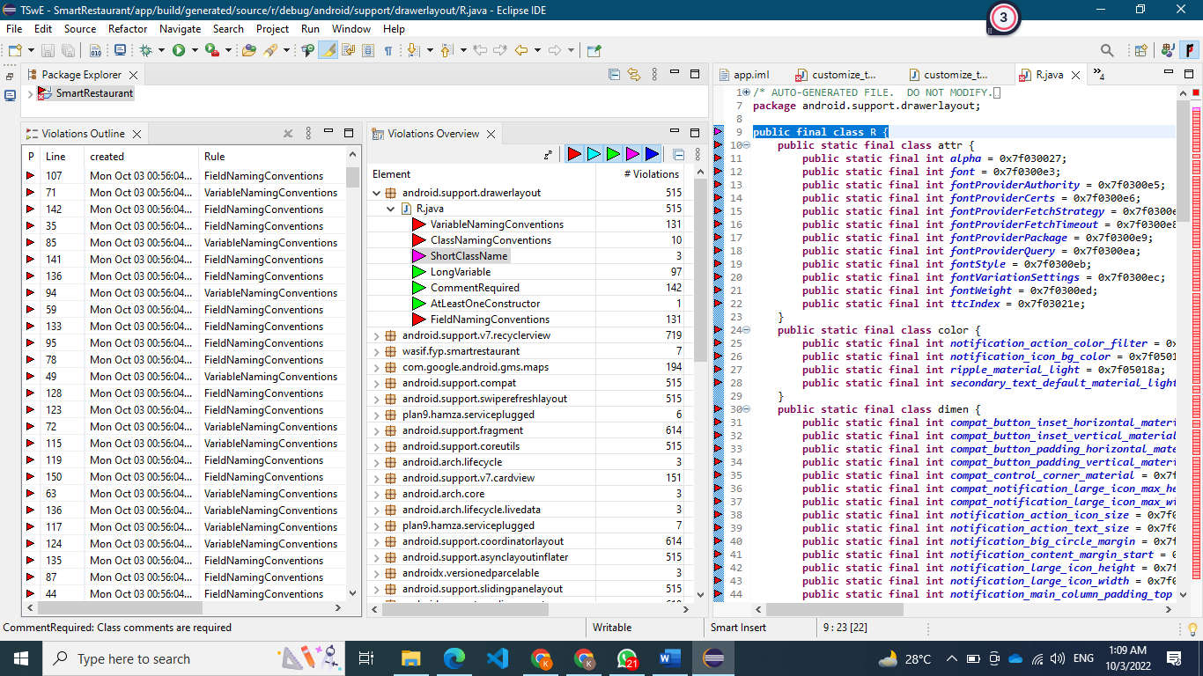

Local variable name could be final declared

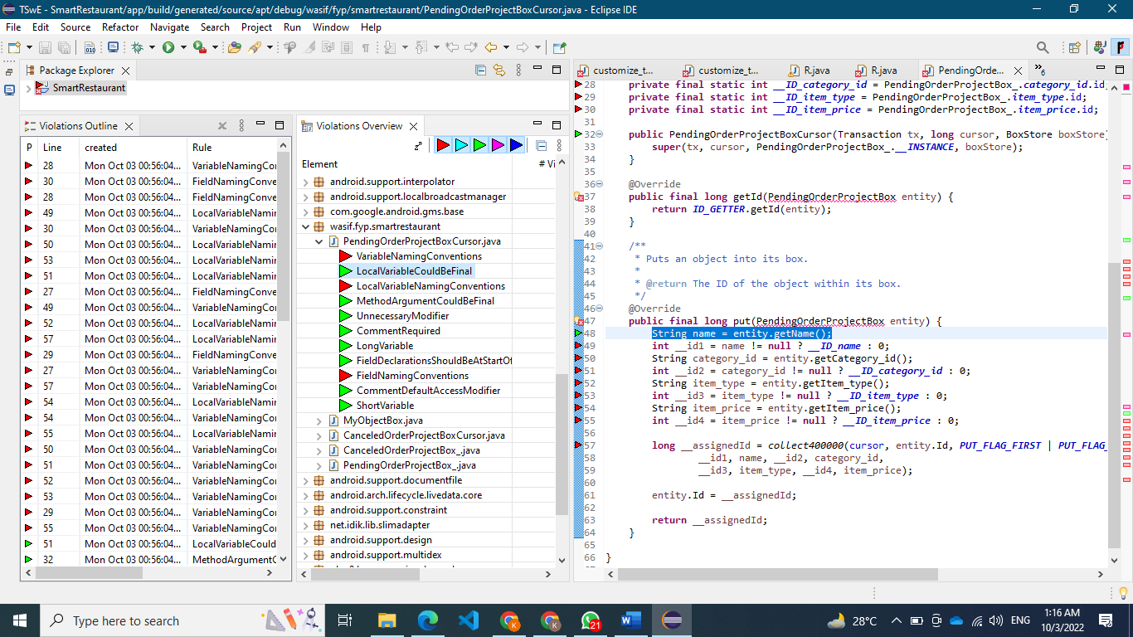

The comment is to large, comment should be short and comprehensive

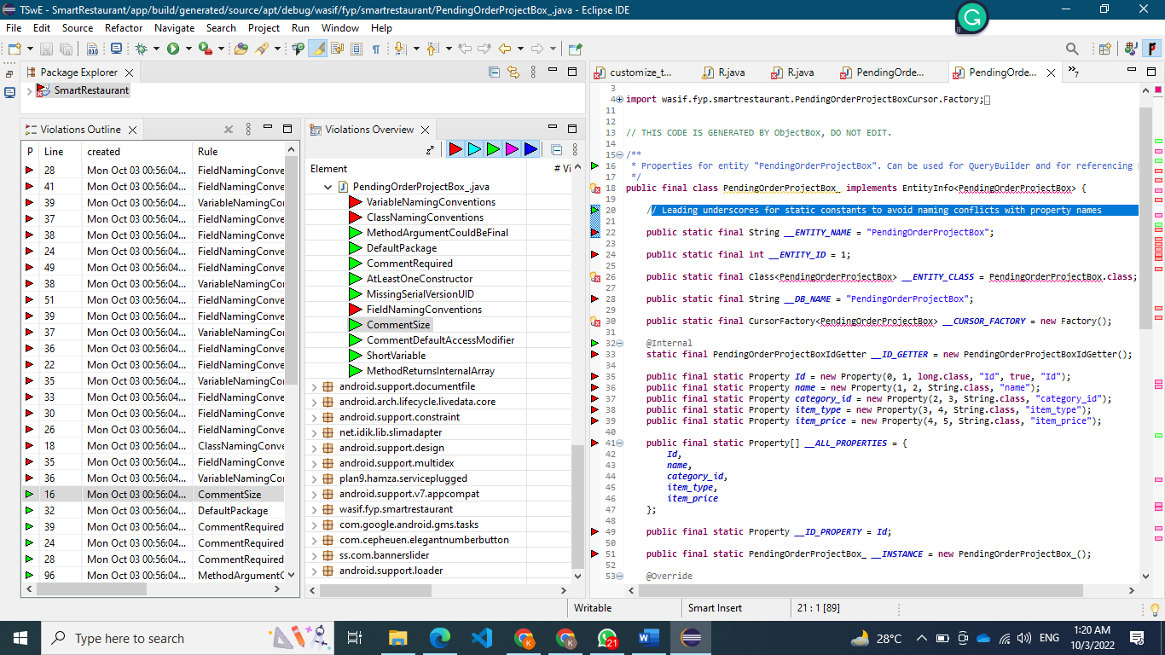

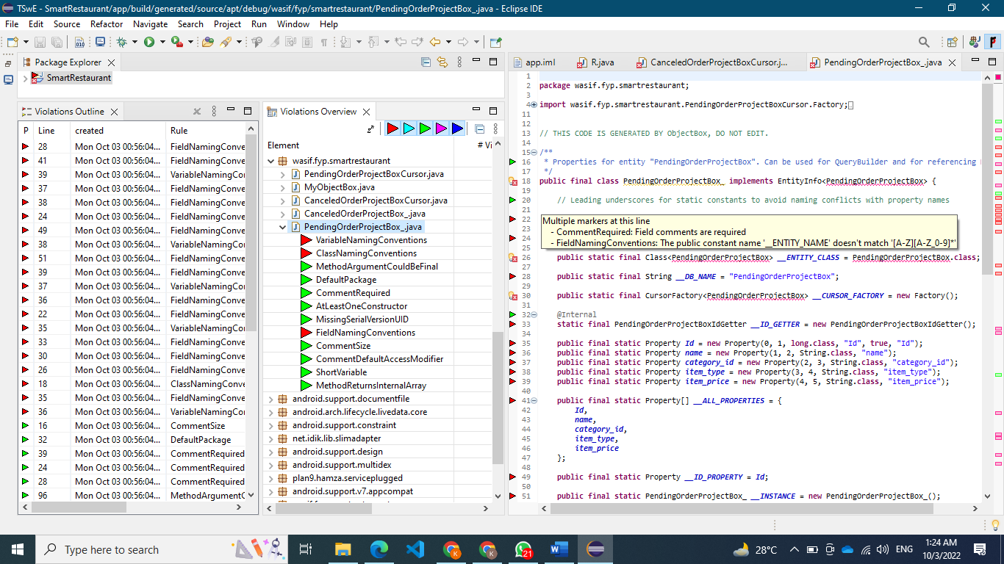

Q2:

5: AST view:

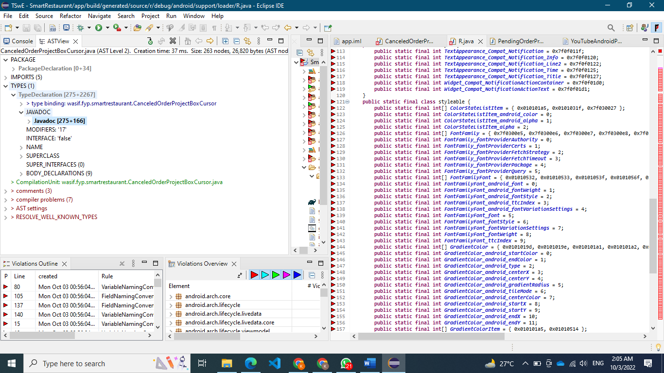

C:

Check style issues:

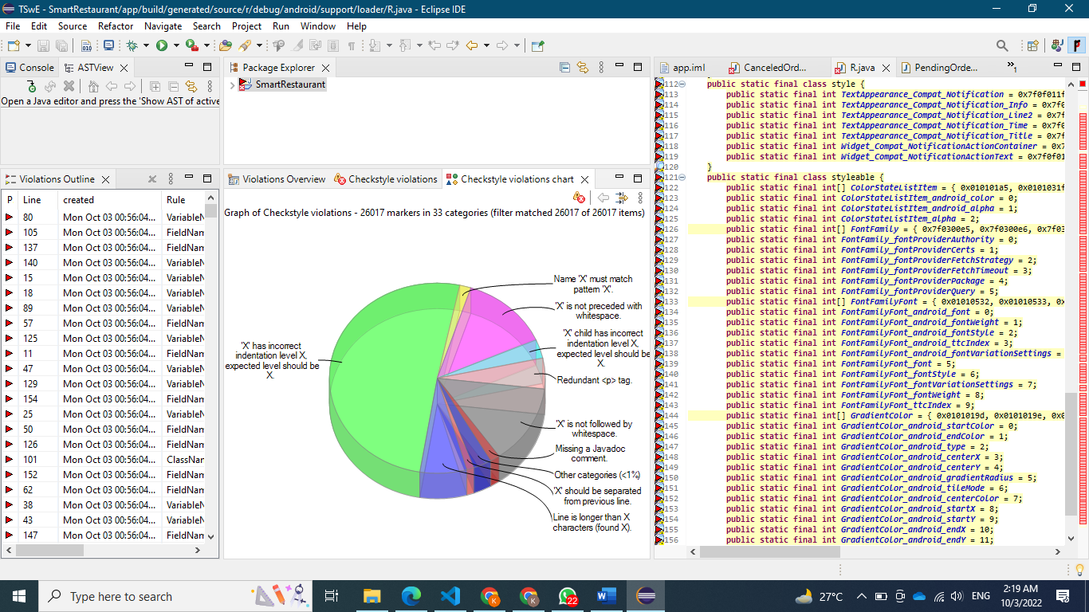

First issue:

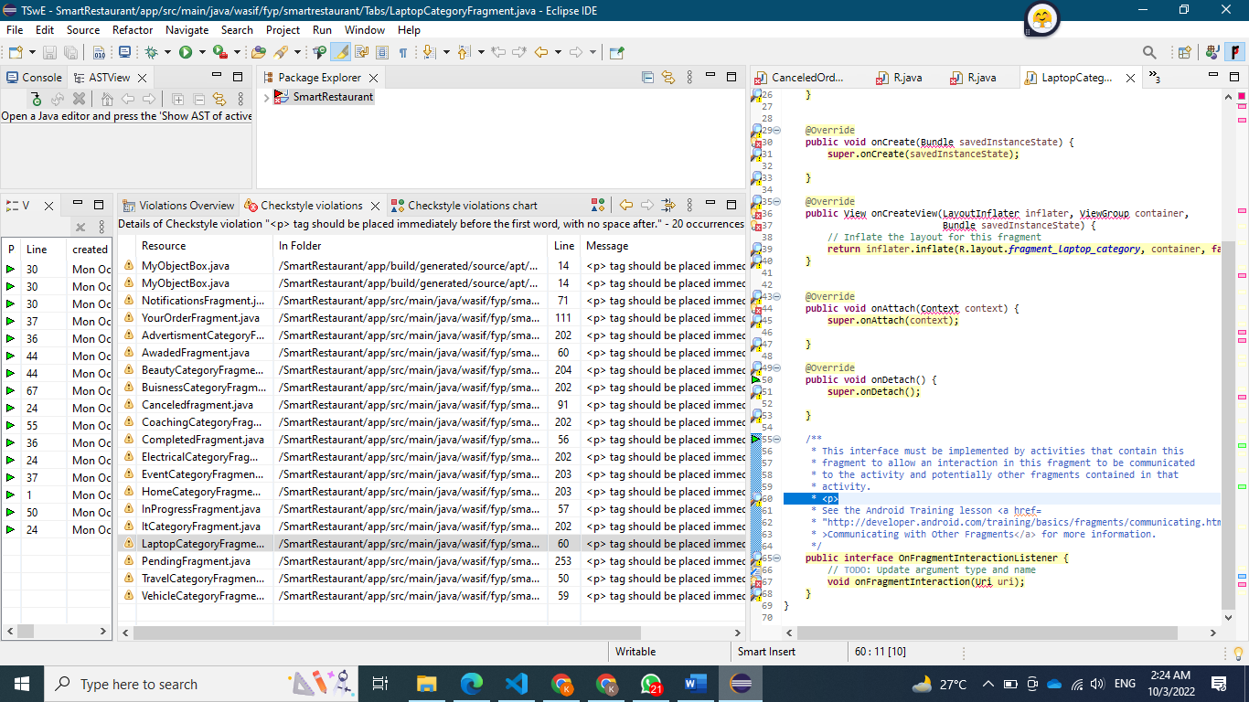

Indentation is also the problem of check style. For making your code indent we can use a tool or put code into visual studio code it automatically invited